Heatsync Labs Turning 101

Rule #1 = Be aware of your surroundings! Always know what’s going on or about to happen before it happens. Think Safety!

Rule #2 = Ask questions. The fastest way to learn is to ask (not break and ask later).

Rule #3 = Have fun while respecting your equipment. Keep it clean, organized, and serviced. It in turn will respect you.

Purpose for Turning
A Lathe is used commonly for removing material from Round parts or parts with cylindrical features. It can be used for drilling, turning, facing, boring, grooving, single point threading, and parting off.

Common turning tool uses

- Drill bits: remove material in an axial direction only.

- Turning tools: Remove material from the outer diameter of the part and/or face of the part.

- Boring tools: Remove material from the inner diameter of the part and/or face of the part.

- Grooving tools: Remove material leaving a radial slot in the part.

- Threading tools: These tools are usually 60 degree pointed tools that cut multiple passes into the part in order to form a thread.

- Part off tools: These tools can be very similar to regular groove tools but are primarily meant to cut deep grooves. Normally you separate your part from the parent material with a parting tool.

Turning Tools  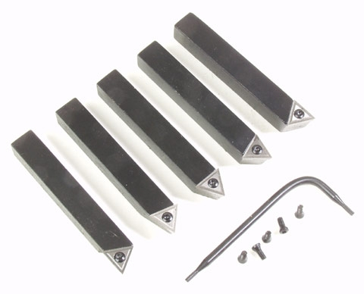 | Grooving  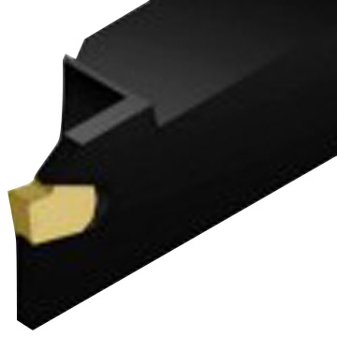 | Threading Tools 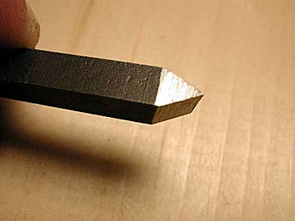
Drill bits  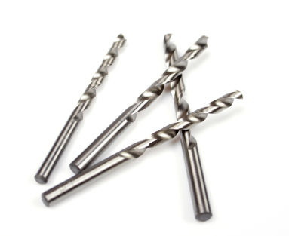 | Boring Bars  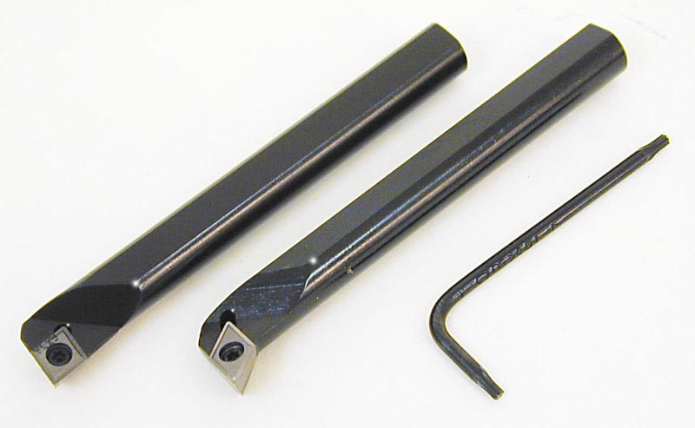 | Part off tools  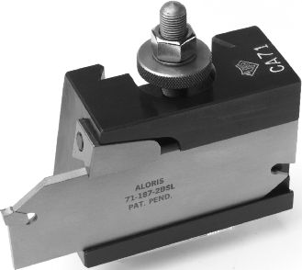

Turning | Grooving | Single Point Threading
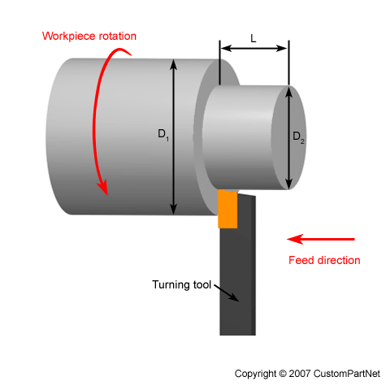 | 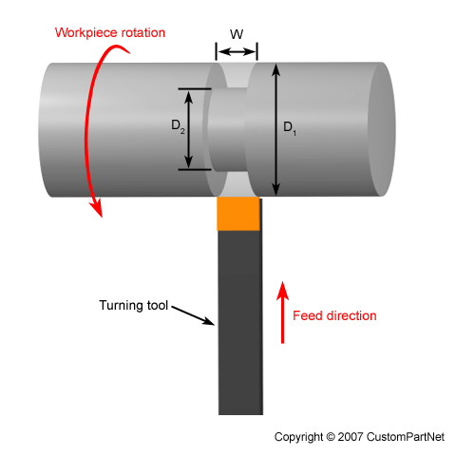 | 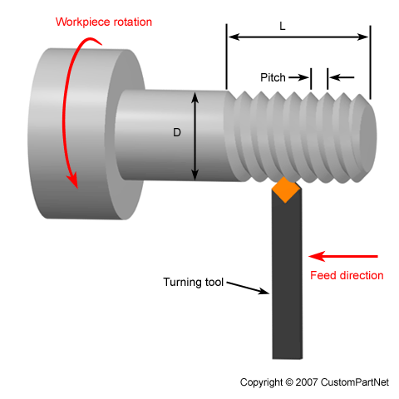
Drilling / Hole Making | Boring | Part Off
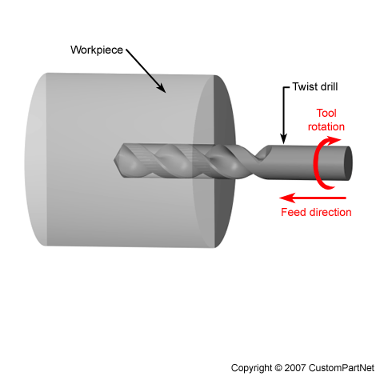 | 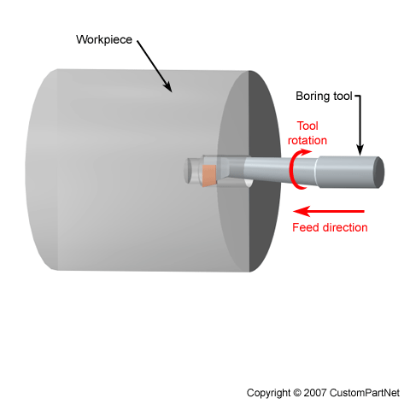 | 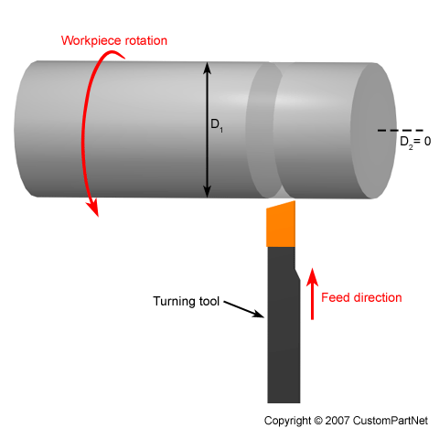

Machining Information

First thing when determining cutting conditions is to evaluate your equipment and cutting tools. The goal is to have as rigid a setup as possible. This means a sturdy machine, Collet chuck or other scroll type chucks, and good condition cutting tools. When rigidity goes up so does part quality and your safety. Always make sure your part is chucked up tightly. Once everything is setup and warmed up you are now ready to turn some parts. Below you will find some steps for finding the correct speed/rpm you should run your cutting tools at while machining. For more information about cutting speeds a simple google search, purchase the Machinery’s handbook (I highly recommend purchasing), or contacting local cutting tool distributors and asking for literature on cutting tools. I will give you a “very basic” rule of thumb/safe starting point for steel and aluminum that you can calculate the proper RPM to run the tool at.

The formula for RPM is
RPM= ( CS / Tool Diameter ) * 3.82

Cutting speeds for drilling:
Steel (1018 CR ) = 90
AL ( 6061-T6 ) = 400
Cutting speeds for turning:
Steel (1018 CR ) = 110
AL ( 6061-T6 ) = 600

The numbers given above are assuming you have a rigid setup and are using a flood type coolant (spraying coolant on it with a squirt bottle will work). If you don’t have coolant you will most likely have to slow your rpm down by about 25% or more in some cases.

Important information when dealing with aluminum! If your cutting tool is TiN coated (a gold looking color) it is technically not supposed to be used on aluminum, The coating welds to aluminum really easy. If you do use it on aluminum, because you can, it might require more coolant/lubrication than other materials. The tool might tend to “clog” up easily or in some cases might break the tool.

Backlash
What is it and how do you live with it? Well, backlash is the slop in the ball screws on each machine axis. It is a problem that plagues all machines. However some machines have specific features to compensate for it. Most manual machines do not have any compensation ability (besides you). This added slop can allow the cutting to “jump” into the part being machined. Sometimes it breaks the tool, sometimes it yanks the part out of the spindle, and sometimes you get lucky and nothing happens other than a minor blemish on your part.
Cutting conditions / turning tips

Depth of cut: A good rule of thumb on smaller machines is to take a radial depth of cut that is about .015-.04 deep for roughing and about half that for finishing.

Make sure the tool tip is on center!!!!! This can be done by slightly pinching a metal scale between the part and the cutting tool tip. If the tool is on center the scale will be aligned vertically.

When threading, set the compound at 29-30 degrees, and feed in radial with the compound. Not the X axis.

Sample Part

