Heatsync Labs Milling 101

Rule #1 = Be aware of your surroundings! Always know what’s going on or about to happen before it happens. Think Safety!

Rule #2 = Ask questions. The fastest way to learn is to ask (not break and ask later).

Rule #3 = Have fun while respecting your equipment. Keep it clean, organized, and serviced. It in turn will respect you.

Purpose for Milling
A mill is used commonly for removing material from square shaped parts. It can be used for drilling, side and/or plunge milling, and facing.

Common Milling tool uses
Drill bits: remove material in an axial direction (down) only.

Endmills: remove material best in a radial direction (sideways) but can also
remove material axially. Although not as well. They remove material most efficiently with a large axial depth of cut (up to 150% of diameter deep) and a lighter radial depth of cut (anywhere from 5%-50% of the cutter diameter).

Facemills/ flycutters: Remove material in a radial direction only. They tend to be most efficient with a lighter axial D.O.C and a larger radial D.O.C.

Drill bits  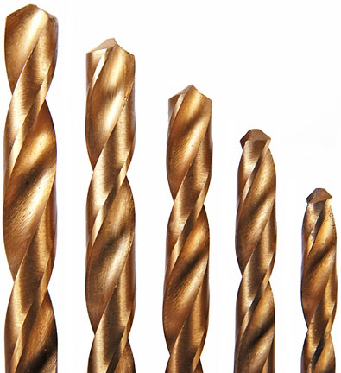 | Endmills  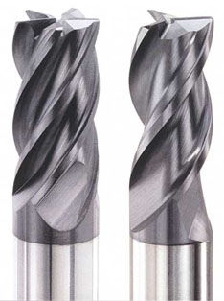 | Face/ Fly cutters  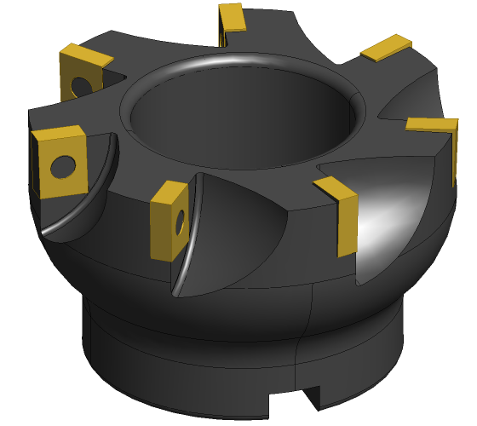  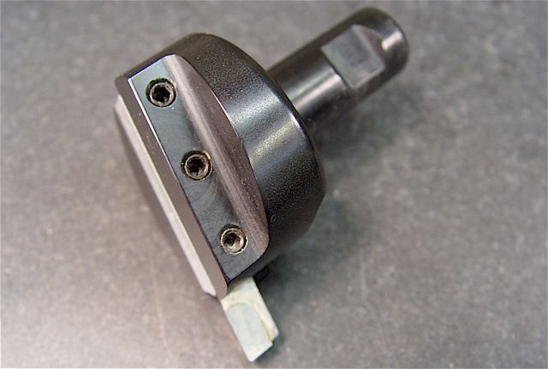

Rule number 1

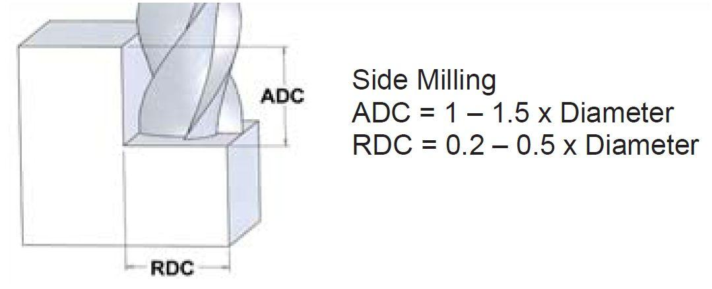

Machining Information

First thing when determining cutting conditions is to evaluate your equipment and cutting tools. The goal is to have as rigid a setup as possible. This means a sturdy machine, strong vice or other work holding devices, and good condition cutting tools. When rigidity goes up so does part quality and your safety. Always make sure your part is clamped tightly and the mill drawbar is tight. Once everything is setup and warmed up you are now ready to make some chips. Below you will find some steps for finding the correct speed/rpm you should run your cutting tools at while machining. For more information about cutting speeds a simple google search, purchase the Machinery’s handbook (I highly recommend purchasing), or contacting local cutting tool distributors and asking for literature on cutting tools. I will give you a “very basic” rule of thumb/safe starting point for steel and aluminum that you can calculate the proper RPM to run the tool at.

The formula for RPM is
RPM= ( CS / Tool Diameter ) * 3.82

Cutting speeds for drilling:
Steel (1018 CR ) = 90
AL ( 6061-T6 ) = 400
Cutting speeds for milling/ facing:
Steel (1018 CR ) = 110
AL ( 6061-T6 ) = 600

The numbers given above are assuming you have a rigid setup and are using a flood type coolant (spraying coolant on it with a squirt bottle will work). If you don’t have coolant you will most likely have to slow your rpm down by about 25% or more in some cases.

Important information when dealing with aluminum! If your cutting tool is TiN coated (a gold looking color) it is technically not supposed to be used on aluminum, The coating welds to aluminum really easy. If you do use it on aluminum, because you can, it might require more coolant/lubrication than other materials. The tool might tend to “clog” up easily or in some cases might break the tool.

Backlash
What is it and how do you live with it? Well, backlash is the slop in the ball screws on each machine axis. It is a problem that plagues all machines. However some machines have specific features to compensate for it. Most manual machines do not have any compensation ability (besides you). This added slop can allow the cutting to “jump” into the part being machined. Sometimes it breaks the tool, sometimes it yanks the part out of the vice, and sometimes you get lucky and nothing happens other than a minor blemish on your part. To fully understand how to avoid this problem it is necessary to understand climb and conventional cutting. The illustration below describes the difference. While climb cutting the tool is allowed to pull through the material (also allowing it to take up the slack in the ball screw and jumping into the part). The conventional cutting strategy is the safest and is the strategy that should be used most on manual machines. It allows the ball screws to be under constant load and wont allow the cutting tool to jump into the part.

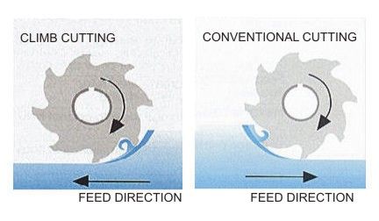

Sample Part
